CARW Exchange Mobile
Access the CARW Commercial Data Exchange on your mobile device – without having to download or maintain mobile updates.
From your mobile device, simply open your web browser and log in to the CARW Commercial Data Exchange the same as you would from your desktop/laptop (http://redicatylist.com/carw/).
The CARW Exchange uses ‘responsive’ technology where it will adjust based on your screen size and resolution. The benefits of this is that you get the full featured system and not a paired down mobile downloaded app.

To make it even easier, you can even create a shortcut on your home screen to tap and go.
iPad or iPhone  - Launch “Safari” app. This does not work from the “Chrome” app.  - Enter into the address field the URL of the website you want to create a shortcut to. Tap “Go.”  - Tap the icon featuring a right-pointing arrow coming out of a box along the top of the Safari window to open a drop-down menu.  - Tap “Add to Home Screen.” The Add to Home dialog box will appear, with the icon that will be used for this website on the left side of the dialog box.  - Enter the name for the shortcut using the on-screen keyboard and tap “Add.” Safari will close automatically and you will be taken to where the icon is located on your iPad’s desktop.  Android  - Launch “Chrome” app.  - Open the website or web page you want to pin to your home screen.  - Tap the menu icon (3 dots in upper right-hand corner) and tap Add to homescreen.  - You’ll be able to enter a name for the shortcut and then Chrome will add it to your home screen. | 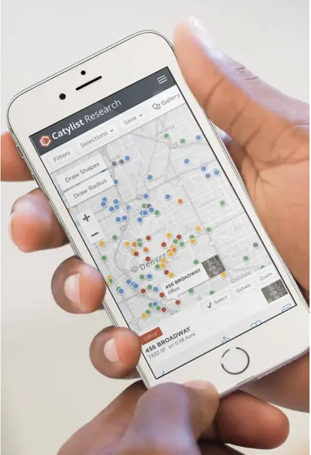
Locate Properties Near you  By clicking on ‘Properties Near me’, we will *geo locate you and show nearby properties making it even easier for prospecting or pulling up property information quickly.  *If you are connected to WiFi, your geo location will be your nearest general router. If you are using cellular data, we will geo locate you to global GPS standards which is 16’ in an open sky location. | 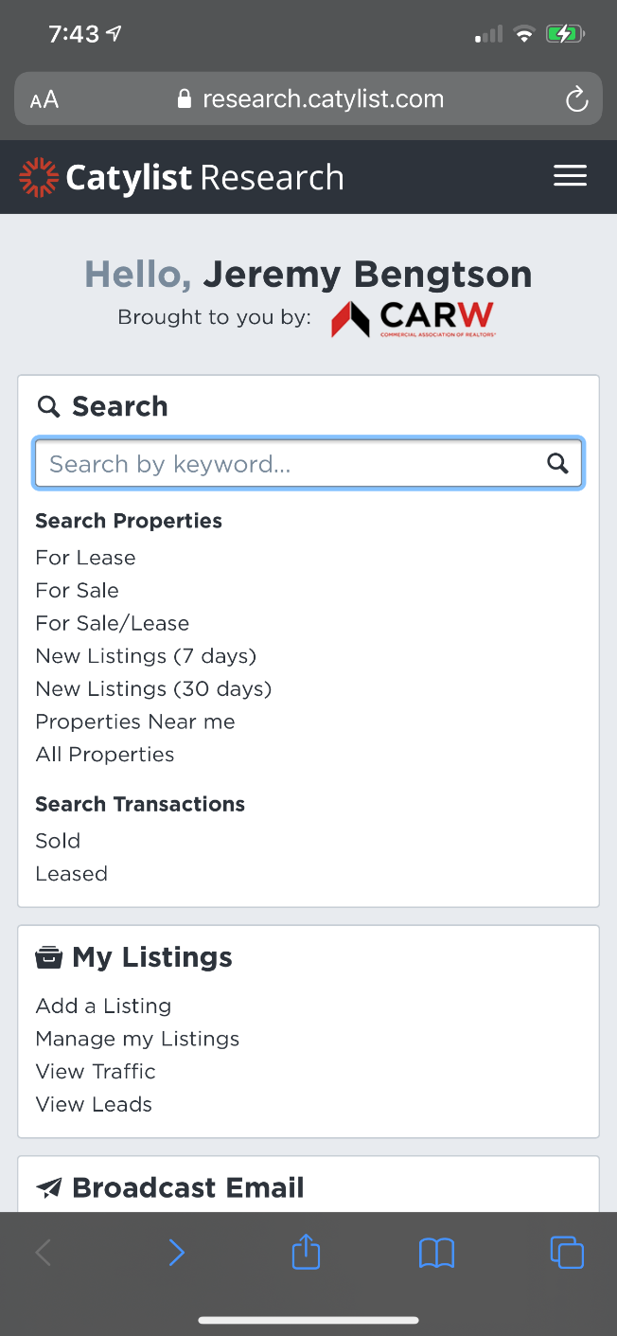

Contact us at 800-574-9183 x803.

Join us Tuesday’s or Thursday’s on our LIVE Exchange System overviews. RSVP here

Click Here to become a CARW Commercial Data Exchange Member, lock your rates of just $115/mo guaranteed through December 31st, 2022, and join the hundreds of CARW Members united together for the most complete, accurate, and cost effective marketing and data research service. Please contact us at info@redicatylist.com or 800-574-9185 x803 if you have any questions. See more at http://redicatylist.com/carw/

The CARW Commercial Data Exchange is Researched by REDI and Powered by Catylist.

