Embed Virtual Tours into Listings
With in-person property visits slowing considerably, real estate brokers are turning to virtual technologies for client engagement and to keep deal flow moving. Please find instructions below on how to embed virtual tours with your listings. We hope this will help you "show" properties a little easier from a distance.
We welcome member feedback - now and always. If you have any suggestions about how to better our service for you during the current environment, please contact us.
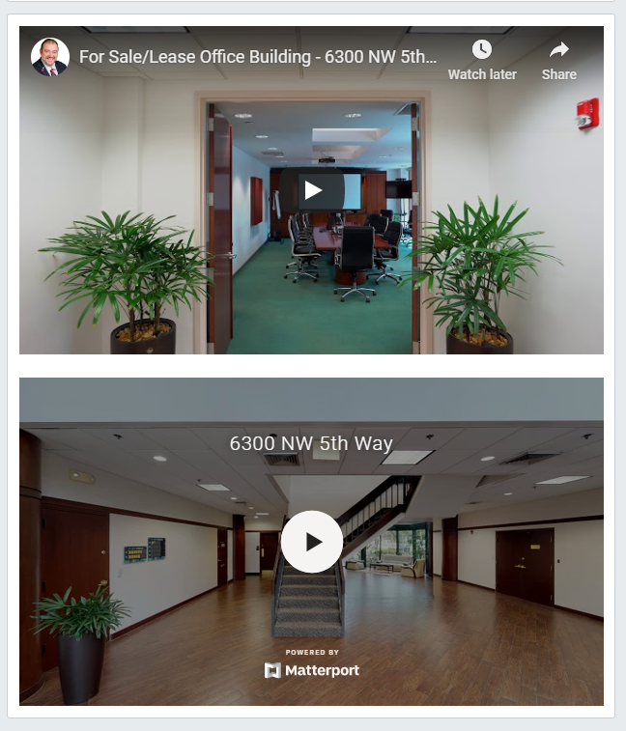
Instructions

1. Log into your Catylist Research account and choose "Manage my Listings" from your dashboard.
2. Choose the "Show # Space" button on the address you'd like to add the video.
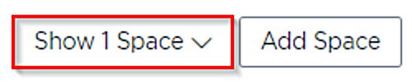
3. Next, click the "Edit" button that appears to the right of the specific listing.
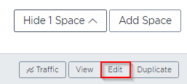
4. Scroll down until you reach the "Links" section and choose "Add a Link".
5. Pop in the description and the URL/link where the video is hosted (YouTube, Vimeo or Matterport VR), and make sure the "Video" box is selected before saving.
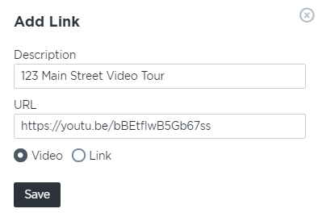
6. Be sure to hit the "Submit Changes" button at the bottom of the page before closing out.
You will now see these videos embedded at the bottom of your listing details page and, once approved by your Research Team, others viewing the listing will be able to see them.

You can also Search for Listings that include Virtual Tours. This option can be found under the ‘More’ search filters menu bar, by selecting ‘Virtual Tour’.
