New and improved ‘Lists’
Lists help you organize, track, and group properties and listings of interest. Use Lists for managing potential availabilities and tours for Clients, or for pulling together a list of comps. The list of uses is endless.
Start by logging in to CARW’s Wisconsin Commercial Data Exchange (http://redicatylist.com/carw/) and click “Lists” from the top blue menu bar. 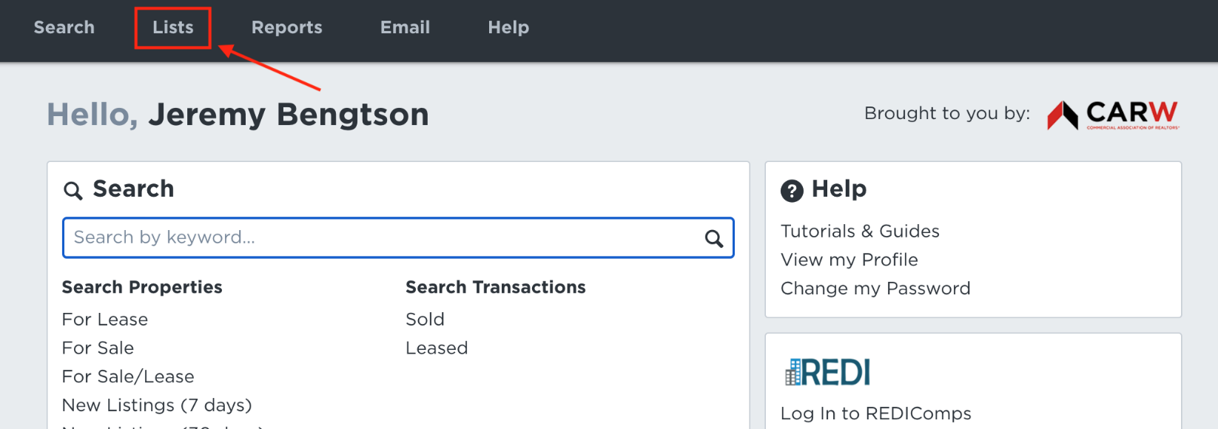

Create a New List by choosing ‘New List’ from the upper right of the page.
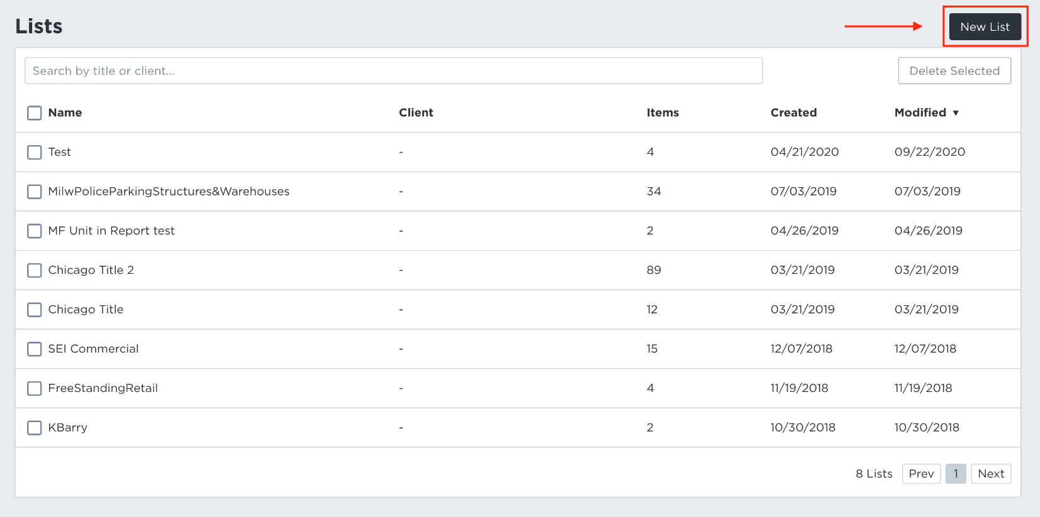
Name your New List (Project name, etc.). *Options include adding a Client Name, and sharing the list with a co-worker by adding their name under ‘Presenters’ field.
Click Save
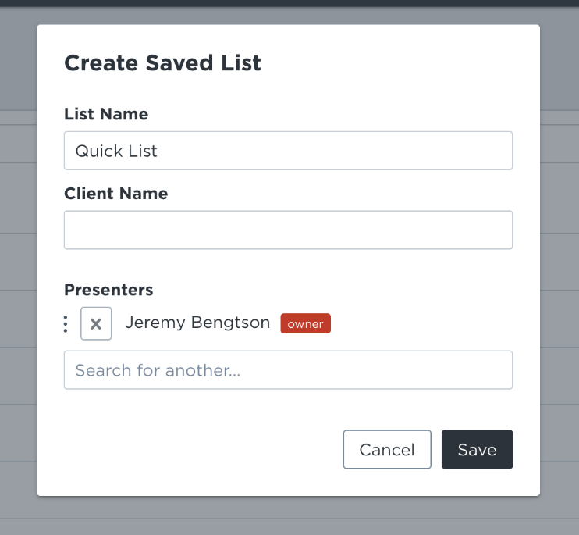
Next, choose which properties and or listings that fit your list needs. You can choose properties/listings of interest from the map view, or from the detail view and then add them to your List.
Map View Example | Detail View Example
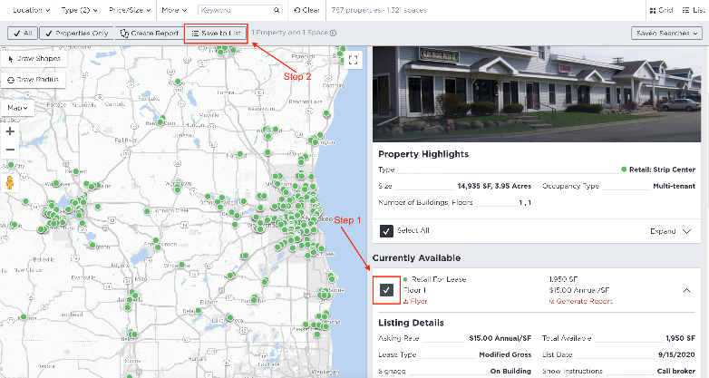 | 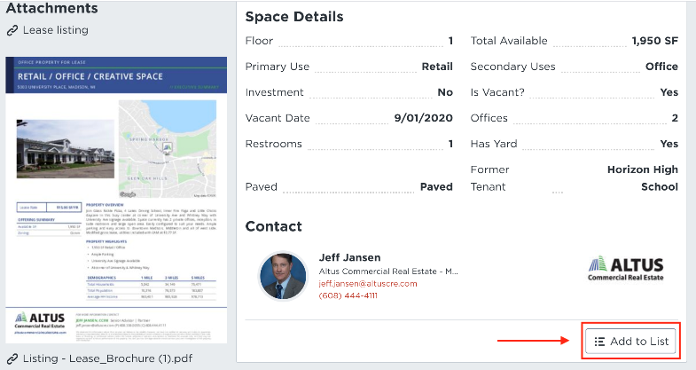

Anytime you want to see your list, click “Lists” from the top blue menu bar. You can add more listings at a later date such as if you have a ‘Saved Search’ set up and a new potential property or listing is emailed to you. You can generate various reports, Google Earth maps, re-name, delete properties or listings from your List, or delete the entire List from the ‘List’ tool.
Click Here to see more on CARW’s Wisconsin Commercial Data Exchange or call us for a demo and membership options at 800-574-9185 x803.

